https://www.tinkercad.com/things/8CCLxiMpH02-amazing-migelo/editel

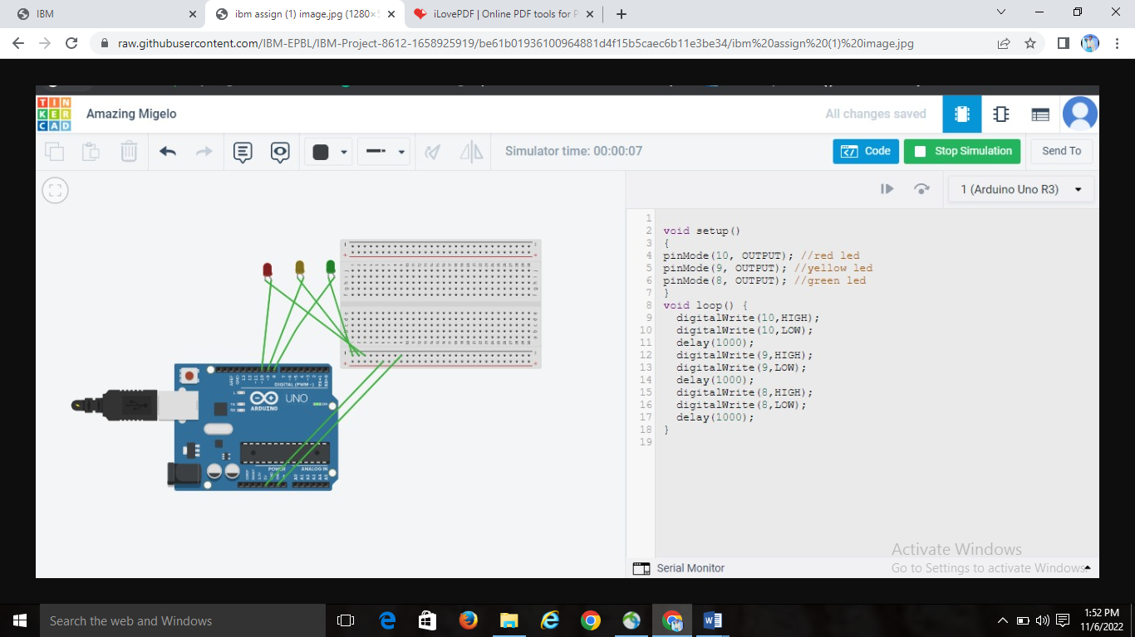

void setup()

{

pinMode(10, OUTPUT); //red led

pinMode(9, OUTPUT); //yellow led

pinMode(8, OUTPUT); //green led

}

void loop() {

digitalWrite(10,HIGH);

digitalWrite(10,LOW);

delay(1000);

digitalWrite(9,HIGH);

digitalWrite(9,LOW);

delay(1000);

digitalWrite(8,HIGH);

digitalWrite(8,LOW);

delay(1000);

}